The state of Human Rights in Somalia

Team members:
Damian Keliš
Eugen Mekovec
Domagoj Šurbek

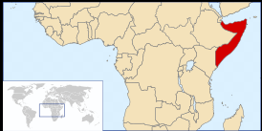

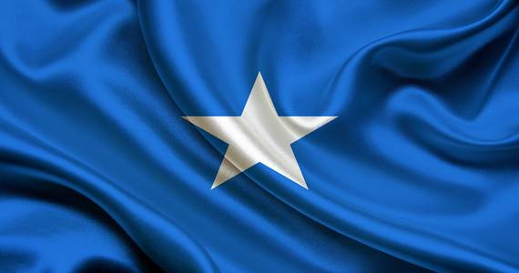

Table of Content

Data for the presentation of the country 3
Justification for the choice of country 4
Human rights that are violated 5
Proposals for improvement 6
Bibliography and sources consulted 7

Data for the presentation of the country

Somalia has 12.1 milion people in their country in 2021.
The president of Somalia is Mohamed Abdullahi Mohamed
Because Somalia does not have minimum wage, there is no mandatory minimum rate of pay for workers in Somalia.
Its borders are with Etiopia, Djibouti, Kenya
Somalia | Spain
The price of coffe in Somalia is 2 euro | Coffee is usually around 1 Euro
Price of bread is usually 0.17 euro | Price of bread is usually 1 euro
GDP=GDP per capita (Purchasing Power Parity) $800 (2020 est.) | GDP per capita (Purchasing Power Parity) $36,200 (2020 est.)

Justification for the choice of country

We chose this country because its current state is not very good.
Alot of fights are going on there.somalie is very poor country.
In somalia most people are discriminated.
Most people in somalia are not in a very good position, because they dont have homes and prices are really high
Kids in Somalia go to army when they are 10 years old. With that little kids are discriminated.
.
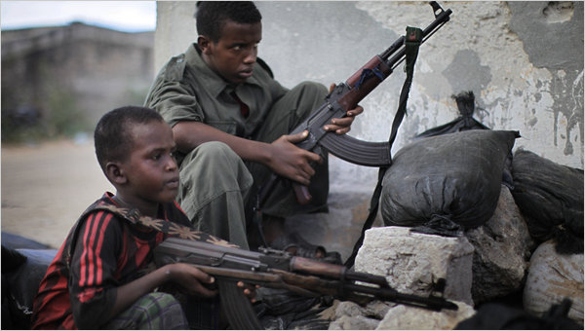
.
.
.
.
.
.
.

Human rights that are violated

Human rights, freedom of expression, information and media freedom and violated the freedom of speech are violated.

Seventeen-year-old cameraman Abdirirzak Qassim Iman was killed by a police bullet on 26 July 2018, while returning home from Waberi district.
The quest for a positive image has led the authorities in Somalia to embrace repressive tactics that fly in the face of international human rights standards.
From barely surviving explosive-wired cars, being shot, beaten up and arrested, journalists are working in terrifying conditions.
Killing of human rights activist underlines need for civilian protection
The death of prominent Somali-Canadian human rights activist Almaas Elman, who was shot, shows the risk faced by activists in the country and underlines the need for the authorities to ensure the safety of civilians, said Amnesty International.
Authorities must launch an investigation into Almaas’ killing and ensure that it is impartial.

Proposals for improvement

Our proposal is that the government should change so that everyone could leave in peace and every single member of every terrorist group should be arrested.
The UN could help out Somalia with repairs and paying of their debt to other countries.

Bibliography and sources consulted

https://commons.wikimedia.org/wiki/File:LocationSomalia.svg
Somalija - stanovništvo, geografska karta i položaj, glavni grad | Svet Pedija
https://static01.nyt.com/images/2010/06/14/world/14somaliacnd_337-span/14somaliacnd_337-span-articleLarge.jpg
https://www.cia.gov/the-world-factbook/static/295d9f8fad69042411c045a78b7e9070/SO-summary.pdf
https://static01.nyt.com/images/2010/06/14/world/14somaliacnd_337-span/14somaliacnd_337-span-articleLarge.jpg

