The states of Human Rights in Belarus
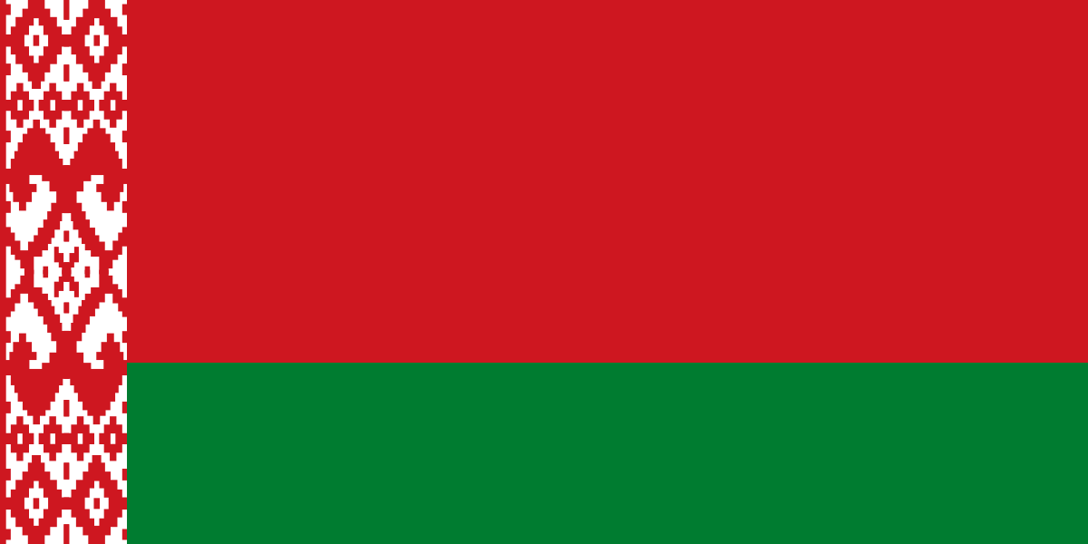

Team members:
Franko Prikratki
Irma Babić
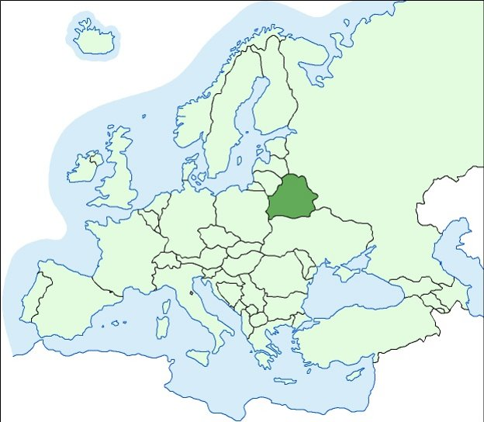
Irma Cikač

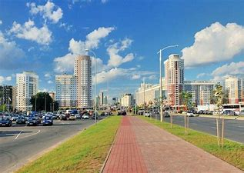

Table of content
Data for the presentation of the country 1
Justification for the choice of country 2
Human rights that are violated 3
Proposals for improvement 4
Bibliography and sources consulted 5
Resources 6

1.Data for the presentation of the country

Belarus is located in Eastern Europe and borders Latvia, Lithuania, Poland, Russia and Ukraine. According to the latest dana, Belarus has a population of 9,441,842 citizens. The population density is 45.5 people per km². GDP amounts 60.26 billion USD and GDP per capita is 6411.23 USD. HDI sums up to 0.823. Belarus is a presidential republic, but in reality a dictatorship. Alexander Lukashenko rules the country.

 | GDP | GDP per capita | HDI | population | political system
Belarus | 60.26 billion USD | 6411.23 USD | 0.823 | 9,441,842 | presidential republic
Spain | 1,281 trillion USD | 27,057.16 USD | 0.904 | 47,260,584 | kingdom

2.Justification for the choice of country

We have chosen this country because we read on the internet about the deverted plane that landed in Belarus. We thought that was interesting. We want to raise awareness about injustice that is happening in Belarus.

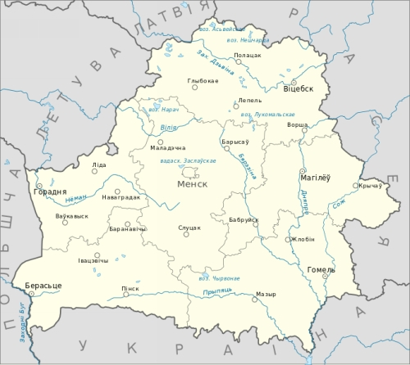

3.Human rights that are violated

One of the problems is authority using torture against people during protests. UN human rights experts received videos and photos that prove protesters were tortured during arrest, transportation and arrest.
People in Belarus were not allowed to have their own opinions. If they said something against the president, there would be high chance of them getting exiled. Once, the authorities kidnapped an opposition leader and drove her to the boarder of Ukraine so they were forced to leave the country.
At the start of pandemic, the government of Belarus was barely responding to endangered health of the citizens in Belarus.
We think authorities should not use torture or imprisonment as a threat. A basic human right is openly speaking about everybody's opinions. People should not be punished for criticizing government or president.

4.Proposals for improvement

We think authorities should not use torture or imprisonment as a threat. A basic human right is openly speaking about everybody's opinions. People should not be punished for criticizing government or president.
We believe that the first step to improvement is holding free elections and letting people choose their leaders.

5.Bibliography and sources consulted
Amnesty International (2020), available at: https://www.amnesty.org/en/location/europe-and-central-asia/belarus/report-belarus/
https://www.worldbank.org/en/search?q=belarus

6.Figures

1. The Flag of Belarus - Figures

2.The Location of Belarus - Figures

3. Minsk, Belarus - Figures
4.Map of Belarus - Figures

