The state of Human Rights in India

group members: Filia Tepšić, Tena Crnčec, Rahel Bakhit

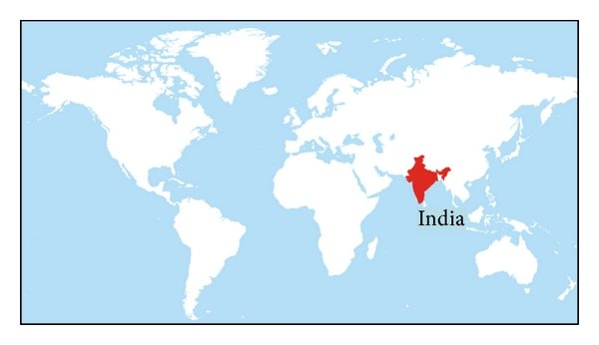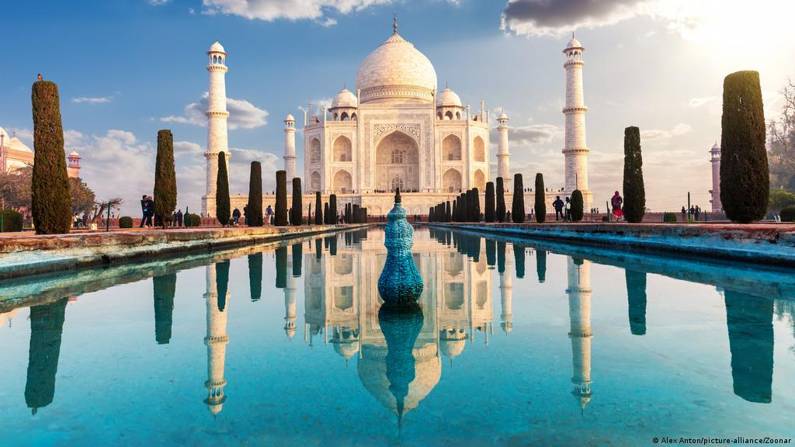
- India is a country in South Asia.
- Seventh largest country in the world.
- India measures 3,214 km from north to south and 2,933 km from east to west.
- Borders of India are: China, Bhutan, Nepal, Pakistan, Bangladesh and Myanmar

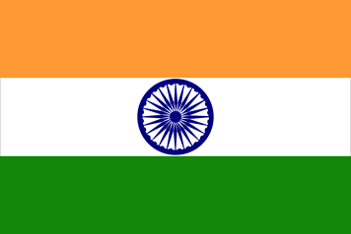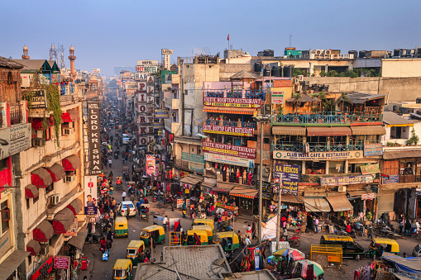
Flag of India.

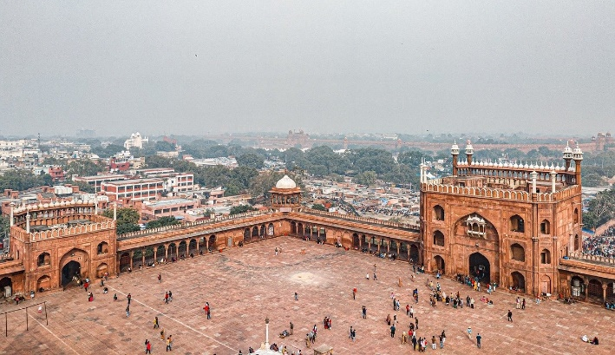
Population of India is 1.40 billion (1,401,717,164)
Head of government in India is Ram Nath Kovind

India is democratic state.

GDP: around 3000.00 billion USD
GDP per capita: around 1850.00 USD

HDI
India dropped two ranks in the United Nations Human Development Index 2021, standing at 131 out of 189 countries.
Last checked India HDI value is 0.645 and Spain HDI is 0.904.

We choose this country because there is a lot to write about it. India is beautiful country and special in it's own way. It has always been one of the most technologically advanced countries in the world. Although it is beautiful and unique it has a lot of problems. A lot of violence against woman and children, injustice for migrants and disrespect to other religions.

VIOLATING HUMAN RIGHTS: In India there has been many problems which affected human rights. A lot of people there should have rights to life and education and rights for privacy, freedom, health and more but they don't. So, right now we are going to show and explain what kind of violence there is and how can we put an end to it.

Women rights in India
Women rights are human rights. Women deserve same respect as men do. But in India there are many problems about that. Problems faced by women in India are rape, sexual harassment, gender pay gap, domestic violence and torture.
Women should have a right to equal pay, to health and protection.
Example:
Sulli Deals: The Indian Muslim woman 'up for sale' on an app
Woman Hana Khan is a pilot. She saw the fake app thinking it was real, but the app was made just to humiliate muslims. They took their usernames and made fake profils of a 100 muslims. They posted their private photos online and offended them. She was one of those muslims

Children rights in India
Both girls and boy sin India face early marriage, domestic abuse, sexual violence, violence at home and in school, online violence , bullying and child labour.
Example:
India reported over 24 instances of online child sexual abuse during free year period between 2017. to 2020. with 80 percent of the victims being girls below the age of 14.
Migrant rights in India:
Many people think that migrants are bad people, terrorist, but they aren't. They are only looking for a better life. Some of them are from different culture and religion, so they look different or act different but it doesn't mean you can choose violence against them. They are just as special and important like everyone else. We think they deserve a chance to live their life happy and they deserve much more respect.
In india most of them are forced to work at bad conditions, especially high temperatures.
A lot of migrants died beacuse forced working to hard during high temperatures.
Migrants also don't get equal pay as others and they are considered less valuable.

Conclusion: To improve human rights we should volunteer more and dedicate more time focusing on what is important and stand up for somebody that needs help. We should raise our voice, because that little things we can do mean so much to people that are considered less valuable and it can help many people to get motivation they need so they can keep on fighting and realise that they mean much more than they think. We can support one another and with all the technollogy we have, we can join online conversation and say what we think everyone should know.
Amnesty International
INDIA
Available: https://www.amnesty.org/en/location/asia-and-the-pacific/south-asia/india/
Child abuse in India
Available: https://www.business-standard.com/article/current-affairs/india-reported-over-24l-online-child-abuse-cases-in-2017-20-interpol-121111701312_1.html
Women rights
Available: https://www.bbc.com/news/world-asia-india-57764271
The world factbook
Available: https://www.cia.gov/the-world-factbook/countries/india/#government

